DeepZero | iPinYou and CAD - A New Data Solution for Chinese Confirmed Traveller Targeting

DeepZero | iPinYou has partnered with Chinese Civil Aviation Data (CAD) to enhance confirmed Chinese traveler targeting for programmatic activation. Using Data from 700m flight purchases, and historic and new ticket purchases, CAD allows brands to understand the time, destination, class, and reason for travel when building audience segments.

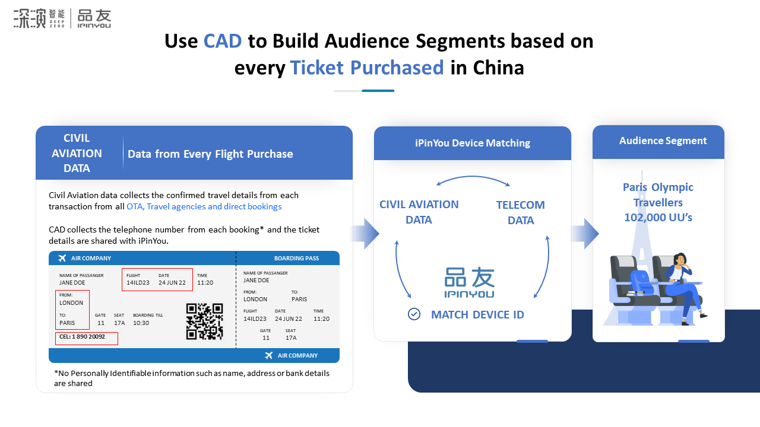

Rather than targeting travelers within travel APPs and OTAs, CAD allows marketers to engage with Chinese travelers across China's leading media through DeepZero | iPinYou's DSP Optimus Prime. The combination of targeting confirmed travelers across the most premium Chinese News, Video, Lifestyle, and Super APPs makes CAD a unique solution for pre-travel targeting.

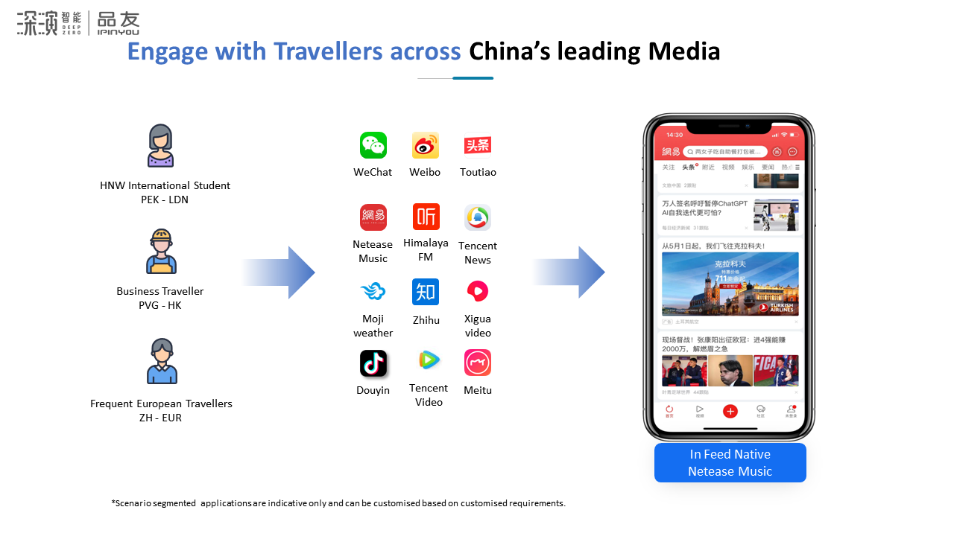

CAD also has the unique ability to target users who have also historically traveled locations around the world, giving luxury, travel, and tourism organizations the opportunity to engage with users with a high propensity to travel or users who have a close affinity to regional products and services.
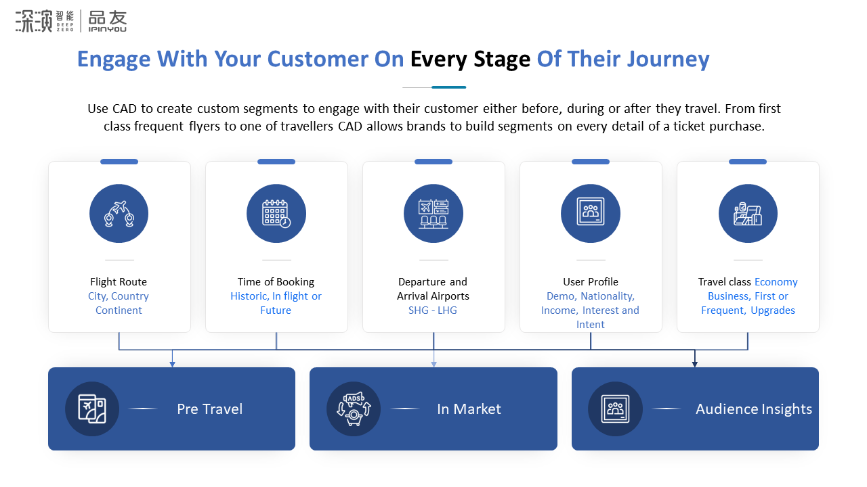

DeepZero | iPinYou will be using CAD data collected during CNY to analyze Chinese travel plans in 2024. With major global events such as the Paris Olympics this summer and Chinese Golden Week in October, CAD will be a useful tool for all brands and marketers to plan their Chinese traveler and travel retail campaigns.

How will Chinese Travel Patterns Change for the Year of the Dragon
According to the "2023 H1 China Outbound Tourism Big Data Report" published by China Tourism Academy, the first half of 2023 has seen a significant increase in travel activity, with Mainland Chinese tourists making approximately 40.37 million trips abroad.

93.95% of travelers opted for short-haul trips within Asia, with East Asia and Southeast Asia being the most popular destinations, accounting for 83.92% and 8.59% of outbound travel, respectively. Among these, Hong Kong, Macao, and Taiwan have emerged as the top choices, drawing 79.89% of the total outbound travel from China. Destinations like Thailand, Singapore, Korea, Malaysia, and Vietnam continue to be favored spots, attracting the majority of Chinese visitors, while long-haul travel to European and North American destinations is also experiencing a steady recovery, with the United States, Australia, the United Kingdom, Canada and Germany ranking high in terms of visitor volume.

Destinations like Thailand, Singapore, Korea, Malaysia, and Vietnam continue to be favored spots, attracting the majority of Chinese visitors, while long-haul travel to European and North American destinations is also experiencing a steady recovery, with the United States, Australia, the United Kingdom, Canada and Germany ranking high in terms of visitor volume.

Looking ahead, the report forecasts that by 2024, the number of inbound and outbound tourist trips is projected to exceed 264 million, with international tourism revenue anticipated to top $107 billion.

The Rise of Chinese Female and Younger Travellers
According to the outbound travel insight released by Mafengwo (a leading OTA), women are leading the charge in outbound travel, accounting for 59.8% of tourists. The youth segment is particularly dominant, with individuals born in 1990-1999 making up 57.1% of these travelers, showcasing a youthful vigor in exploring the world.

Nearly 48.5% of the younger generation who go abroad for travel spend more than 10,000 RMB per person. Another insight indicated that a striking 84% of these global voyagers come from households with a monthly income of 8-20k RMB, highlighting the correlation between disposable income and international travel propensity.

Geographically, urbanization trends are evident. First-tier cities are still the main source of tourists for outbound travel, with the four first-tier cities in Beijing, Shanghai, Guangzhou, and Shenzhen contracting more than 40% of tourists, suggesting that residents of more developed urban areas are more inclined to venture abroad.

The steady recovery in the number of outbound tourists since the pandemic underscores the potential for sustained growth in the travel sector. As restrictions ease and consumer confidence returns, outbound tourism is poised to become a pivotal growth driver for the industry.

Do you want to explore more possibilities with DeepZero | iPinYou and CAD? Reach out to us and let's make this Chinese New Year and the coming holidays a milestone for your brand in the thriving Chinese outbound travel market.

