**Travel Post**

**China's Outbound Tourism Poised for a Strong Comeback in 2024**

As China's Spring Festival welcomed an 8-day holiday period in 2024, there was a surge in outbound travel. With an estimated 360 million trips reported by the Ministry of Culture and Tourism of China, the nation's passion for exploration is back.

The China Tourism Academy projects an accelerated recovery for the inbound and outbound travel market, with expectations to exceed 264 million trips and 107 billion USD in international tourism revenue. Data from Forward Keys shows that China is progressively returning to pre-2019 outbound travel numbers as national travelers are now including international travel as part of their annual plans.

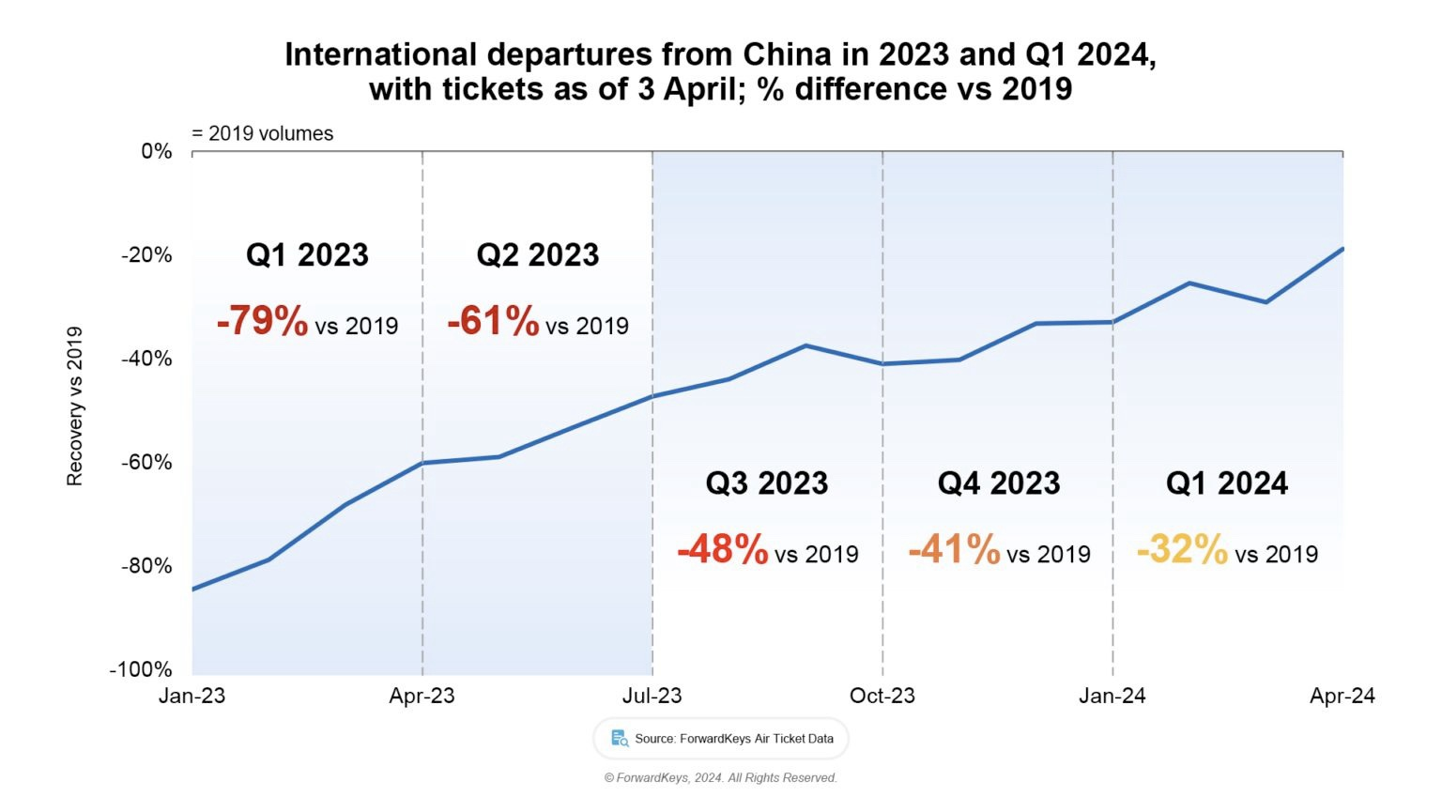

Dai Bin, president of the China Tourism Academy, confirms this optimistic outlook. The post-pandemic rebound that began last year is set to hit its stride, with peak travel periods forecasted during major holidays.

Data from the Civil Aviation Administration of China mirrors this revival, with international flights escalating from less than 500 weekly at the start of 2023 to over 4,600 last week. The momentum is expected to carry forward, projecting a weekly frequency of 6,000 flights. Research from Oliver Wyman suggests that China's outbound tourism market may see a full-scale recovery post the second half of 2024. Destinations such as Hong Kong, Western Europe, Japan, and South Korea are popular among Chinese travelers, who now prioritize shopping over sightseeing, with Gen Z leading the outbound travel trend. This demographic shift signifies a new era for the tourism and retail industries, as businesses will need to cater to the tastes and preferences of these young travelers.

The resurgence of China's outbound tourism is not just a testament to the industry's resilience, but also a beacon of opportunity for international markets. As China reopens its doors to the world, the global tourism landscape is set to welcome a wave of eager travelers ready to indulge in new experiences and retail therapy. To support brands looking to engage with Chinese Travellers iPinYou has utilised [Chinese Civil Aviation Data](https://www.ipinyou.com/news/report/722.html) (CAD) that enables brands to build custom audiences based on the following variables to advertise across China's leading Hero Apps from Ali Pay and iQiYi to Didi and Tencent News:

Destination Airport:

Transit Airport:

Departure Airport:

Time of Travel: Between 180 days before and after travel

Travel Class: Economy, Business, First

Frequency: Single or frequent flyer

To increase travellers attention to locations, products, and services brands can utilize Travel and Lifestyle KOLs (influencers) can be managed through [K-Advisor](https://www.ipinyou.com/solution/kol/). K-Advisor uses data from CAD and Telecom Providers to verify which KOLs are followed by the brand's target audiences to increase the effectiveness of KOL and to ensure it supports travel retail paid media activation.

With the May Day National holiday on the way, iPinYou will continue to monitor key trends within Chinese travel and be ready to support brands who want first access to returning Chinese travelers.

#iPinYou #CAD #ChinaTourism #OutboundTravel #GlobalTourism #GenerationZ #LaborDayTravel #Martech #TravelMarketing #DigitalAdvertising

